July 11, 2021
Pastor Joseph Britain

You will know the truth and the truth will set you free (John 8:32)

Get on a budget

Get free from debt

Establish a _______________ emergency fund
(Jesus speaking about God the Father) For He causes His sun to rise on the evil and the good, and sends rain on the righteous and the unrighteous. (Matt 5:45b)

__________ borrowing money
The borrower becomes the lender’s slave (Prov 22:7b)

Owe nothing to anyone except to love one another (Rom 13:8a)

Have a __________________ to pay them all off
Good planning and hard work lead to prosperity, but hasty shortcuts lead to poverty (Prov 21:5 NLT)

God Himself will ________ you
Remember this - a farmer who plants only a few seeds will get a small crop. But the one who plants generously will get a generous crop. You must each decide in your heart how much to give. And don’t give reluctantly or in response to pressure. “For God loves a person who gives cheerfully.” And God will generously provide all you need. Then you will always have everything you need and plenty left over to share with others. As the Scriptures say, “They share freely and give generously to the poor. Their good deeds will be remembered forever.” For God is the one who provides seed for the farmer and then bread to eat. In the same way, He will provide and increase your resources and then produce a great harvest of generosity in you. Yes, you will be enriched in every way so that you can always be generous. (2Cor 9:6-11a NLT)

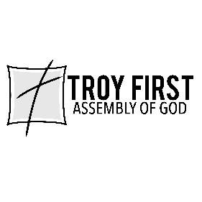

All scripture is from the New American Standard Version unless otherwise noted

