August 30, 2020
Pastor Joseph Britain

FATIGUE

Jesus not only understands - He’s _____ ______
And He (Jesus) said to them (the disciples), “Come away by yourselves to a secluded place and rest a while.” (For there were many people coming and going, and they did not even have time to eat.) They went away in the boat to a secluded place by themselves. The people saw them going, and many recognized them and ran there together on foot from all the cities, and got there ahead of them. (Mark 6:31-33)

Then Jesus left Galilee and went north to the region of Tyre. He didn’t want anyone to know which house He was staying in, but He couldn’t keep it a secret. (Mark 7:24 NLT)

“Come to Me, all who are weary and heavy-laden, and I will give you rest. Take My yoke upon you and learn from Me, for I am gentle and humble in heart, and you will find rest for your souls. For My yoke is easy and My burden is light.” (Matt 11:28-30)

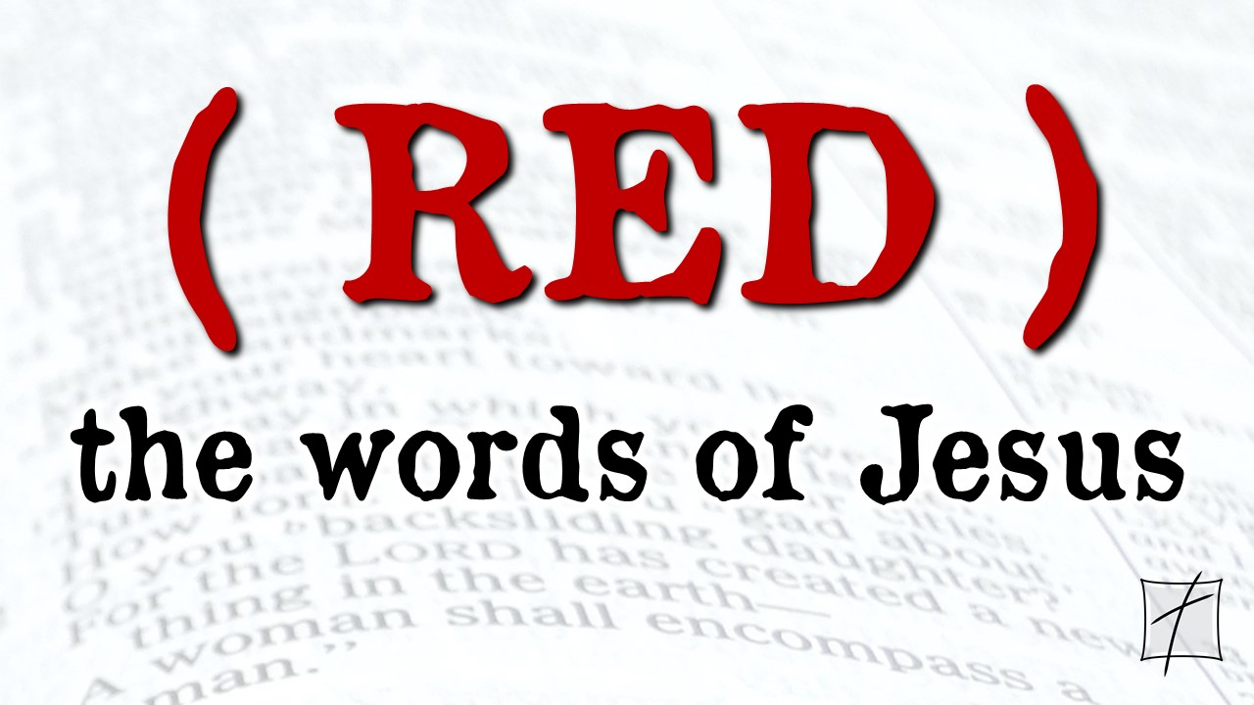

Jesus said, “Come to _____”
Jacob’s well was there; and Jesus, tired from the long walk, sat wearily beside the well about noontime. (John 4:6 NLT) :28-30)

Jesus said, “I will __________ you”
“Come to Me, all who are weary and heavy-laden, and I will give you rest.” (Matt 11:28)

Jesus said, “Get in the ________ with Me”
“Take My yoke upon you and learn from Me, for I am gentle and humble in heart, and you will find rest for your souls. For My yoke is easy and My burden is light.”
(Matt 11:29-30)

Jesus said, “You will _______ rest for your soul”
“Take My yoke upon you and learn from Me, for I am gentle and humble in heart, and you will find rest for your souls. For My yoke is easy and My burden is light.”
(Matt 11:29-30)

All scripture is from the New American Standard Version unless otherwise noted

