December 16, 2020
Pastor Joseph Britain

“Self Control” in the Greek is ________________
For the good that I want, I do not do, but I practice the very evil that I do not want. (Rom 7:19)

Wretched man that I am! Who will set me free from the body of this death? (Rom 7:24)

I can do all things through Him Who strengthens me (Php 4:13)

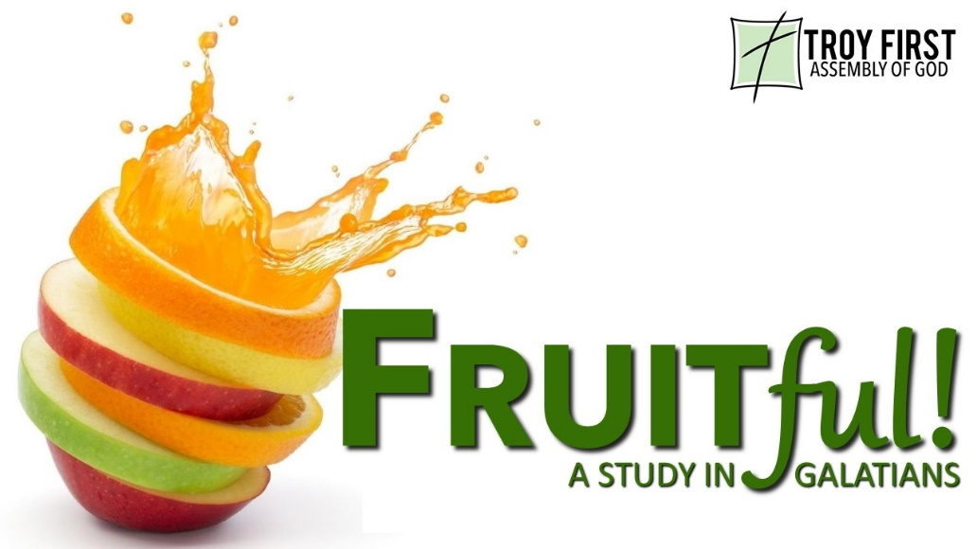

Draw really close to _____________
Have this attitude in yourselves which was also in Christ Jesus, who, as He already existed in the form of God, did not consider equality with God something to be grasped, but emptied Himself (Php 2:5-7a)

Now some days later Felix arrived with Drusilla his wife, who was Jewish, and he sent for Paul and heard him speak about faith in Christ Jesus. But as he was discussing righteousness, self-control, and the judgment to come, Felix became frightened and responded, “Go away for now, and when I have an opportunity, I will summon you.” (Acts 24:24-25)

Developing the fruit in ____________
But the fruit of the Spirit is love, joy, peace, patience, kindness, goodness, faithfulness, gentleness, self-control (Gal 5:22-23a)

We develop self-control through _______________
Work out your own salvation with fear and trembling; for it is God who is at work in you, both to desire and to work for His good pleasure (Php 2:12b-13)

Make every effort to add to your faith goodness; and to goodness, knowledge; and to knowledge, self-control (1Pe 2:5b-6a).

We are taking every thought captive to the obedience of Christ (2 Cor 10:5b)

All scripture is from the New American Standard Version unless otherwise noted

