April 7, 2021
Pastor Joseph Britain

So that no advantage would be taken of us by Satan, for we are not ignorant of his schemes (2Cor 2:11)

Finally, be strong in the Lord and in the strength of His might. Put on the full armor of God, so that you will be able to stand firm against the schemes of the devil. For our struggle is not against flesh and blood, but against the rulers, against the powers, against the world forces of this darkness, against the spiritual forces of wickedness in the heavenly places. Therefore, take up the full armor of God, so that you will be able to resist on the evil day, and having done everything, to stand firm. Stand firm therefore, having belted your waist with truth, and having put on the breastplate of righteousness, and having strapped on your feet the preparation of the gospel of peace; in addition to all, taking up the shield of faith with which you will be able to extinguish all the flaming arrows of the evil one. And take the helmet of salvation and the sword of the Spirit, which is the word of God. With every prayer and request, pray at all times in the Spirit, and with this in view, be alert with all perseverance and every request for all the saints (Eph 6:10-18)

Finally, brothers and sisters, draw your strength and might from God. Put on the full armor of God to protect yourselves from the devil and his evil schemes. We’re not waging war against enemies of flesh and blood alone. No, this fight is against tyrants, against authorities, against supernatural powers and demon princes that slither in the darkness of this world, and against wicked spiritual armies that lurk about in heavenly places. And this is why you need to be head-to-toe in the full armor of God: so you can resist during these evil days and be fully prepared to hold your ground. Yes, stand - truth banded around your waist, righteousness as your chest plate, and feet protected in preparation to proclaim the good news of peace. Don’t forget to raise the shield of faith above all else, so you will be able to extinguish flaming spears hurled at you from the wicked one. Take also the helmet of salvation and the sword of the Spirit, which is the word of God. Pray always. Pray in the Spirit. Pray about everything in every way you know how! And keeping all this in mind, pray on behalf of God’s people. Keep on praying feverishly, and be on the lookout until evil has been stayed (Eph 6:10-18 VOICE)
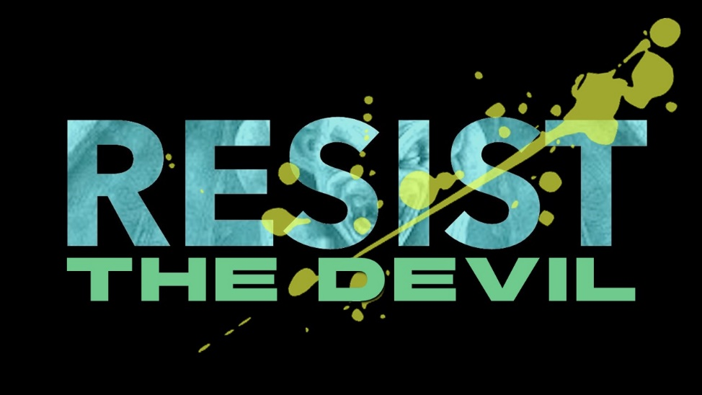
Put on the belt of ____________

Put on the breastplate of _______________________
Above all else, guard your heart, for everything you do flows from it. (Prov 4:23NIV)

He (God) made Him (Jesus) who knew no sin to be sin in our behalf, so that we might become the righteousness of God in Him. (2Cor 5:21)

Put on the footgear of _____________
It was for freedom that Christ set us free; therefore keep standing firm and do not be subject again to a yoke of slavery (Gal 5:1)

Over all of it – Pick up your ____________ shield
... taking up the shield of faith with which you will be able to extinguish all the flaming arrows of the evil one (Eph 6:16b)

Our mind is protected by His __________________

Our one weapon – God’s __________
He (Eleazer) rose up and struck the Philistines until his hand was weary and it clung to the sword, and the Lord brought about a great victory that day; and the people returned after him only to plunder the dead. (2Sam 23:10)

The last piece of armor – Prayer in the ____________
Pray at all times in the Spirit (Eph 6:18b)

But thanks be to God, who always leads us in triumph in Christ, and through us reveals the fragrance of the knowledge of Him in every place. (2Cor 2:14)

All scripture is from the New American Standard Version unless otherwise noted

