September 22, 2021
Pastor Joseph Britain

_____________
The fear of the Lord is the beginning of knowledge; Fools despise wisdom and instruction (Prov 1:7)

But if any of you lacks wisdom, let him ask of God, who gives to all generously and without reproach, and it will be given to him (James 1:5)

Trust in the Lord with all your heart and do not lean on your own understanding. In all your ways acknowledge Him, and He will make your paths straight. (Prov 3:5-6)

Blessed is the one who fears the Lord always, but whoever hardens his heart will fall into calamity (Prov 28:14 ESV)

___________________________
Who can say, “I have cleansed my heart, I am pure from my sin”? (Prov 20:9)

For a righteous person falls seven times and rises again, but the wicked stumble in time of disaster (Prov 24:16)

The steadfast love of the Lord never ceases; His mercies never come to an end; they are new every morning; great is Your faithfulness. (Lam 3:22-23 ESV)

If we say that we have no sin, we are deceiving ourselves and the truth is not in us. If we confess our sins, He is faithful and righteous, so that He will forgive us our sins and cleanse us from all unrighteousness. (1John 1:8-9)

__________________________
This is my beloved and this is my friend (Song of Solomon 5:16b)

A friend loves at all times (Prov 17:17a)

_________
Let your fountain be blessed, and rejoice in the wife of your youth. Like a loving doe and a graceful mountain goat, let her breasts satisfy you at all times; Be exhilarated always with her love. For why should you, my son, be exhilarated with an adulteress, and embrace the breasts of a foreigner? (Prov 5:18-20)

A time to weep and a time to laugh; A time to mourn and a time to dance (Ecc 3:4)

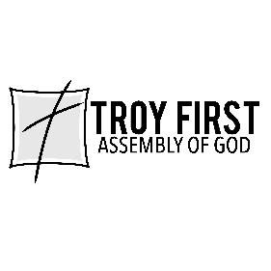

All scripture is from the New American Standard Version unless otherwise noted

