March 24, 2021
Pastor Joseph Britain

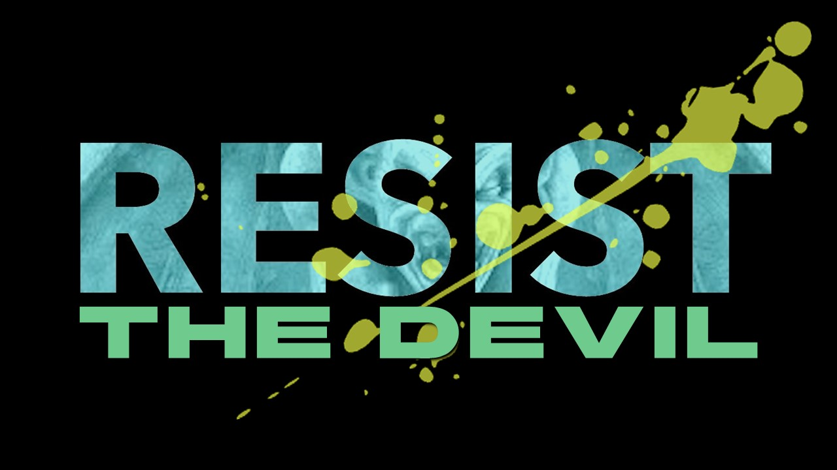
So that no advantage would be taken of us by Satan, for we are not ignorant of his schemes (2Cor 2:11)

Then I heard a loud voice in heaven, saying, “Now the salvation, and the power, and the kingdom of our God and the authority of His Christ have come, for the accuser of our brothers and sisters has been thrown down, the one who accuses them before our God day and night.” (Rev 12:10)

Satan, the accuser, attacks our ____________

The accuser is _______________________
. . . The one who accuses them before our God day and night.” (Rev 12:10b)

No weapon that is formed against you will succeed; and you will condemn every tongue that accuses you in judgment. This is the heritage of the servants of the Lord, and their vindication is from Me,” declares the Lord. (Is 54:17)

_______ goodness was never going to cut it anyway
We are all infected and impure with sin. When we display our righteous deeds, they are nothing but filthy rags. (Is 64:6a NLT)

We come in ________ righteousness
Who will bring charges against God’s elect? God is the one who justifies; who is the one who condemns? (Rom 8:33-34a)

The _____________________ scene
Then he showed me Joshua the high priest standing before the angel of the Lord, and Satan standing at his right to accuse him. And the Lord said to Satan, “The Lord rebuke you, Satan! Indeed, the Lord who has chosen Jerusalem rebuke you! Is this not a log snatched from the fire?” Now Joshua was clothed in filthy garments and was standing before the angel. And he responded and said to those who were standing before him, saying, “Remove the filthy garments from him.” Again he said to him, “See, I have taken your guilt away from you and will clothe you with festive robes.” Then I said, “Have them put a clean headband on his head.” So they put the clean headband on his head and clothed him with garments, while the angel of the Lord was standing by. (Zech 3:1-5)

And the son said to him, “Father, I have sinned against heaven and in your sight; I am no longer worthy to be called your son.” But the father said to his slaves, “Quickly bring out the best robe and put it on him, and put a ring on his finger and sandals on his feet” (Luke 15:21-22)

My dear children, I am writing this to you so that you will not sin. But if anyone does sin, we have an advocate who pleads our case before the Father. He is Jesus Christ, the one who is truly righteous. He himself is the sacrifice that atones for our sins - and not only our sins but the sins of all the world. (1John 2:1-2 NLT)

Don’t side _________ the accuser
Dear brothers and sisters, if another believer is overcome by some sin, you who are godly should gently and humbly help that person back onto the right path. And be careful not to fall into the same temptation yourself. (Gal 6:1 NLT)

But thanks be to God, who always leads us in triumph in Christ, and through us reveals the fragrance of the knowledge of Him in every place. (2Cor 2:14)

All scripture is from the New American Standard Version unless otherwise noted

