September 13, 2020
Pastor Joseph Britain

So do not worry about tomorrow; for tomorrow will care for itself. Each day has enough trouble of its own. (Matt 6:34)

Give us this day our daily bread. (Matt 6:11)

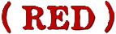
The Greek word for ___________

In RED, “Do not worry” is a ________________
Do not worry then, saying, ‘What will we eat?’ or ‘What will we drink?’ or ‘What will we wear for clothing?’ (Matt 6:31)

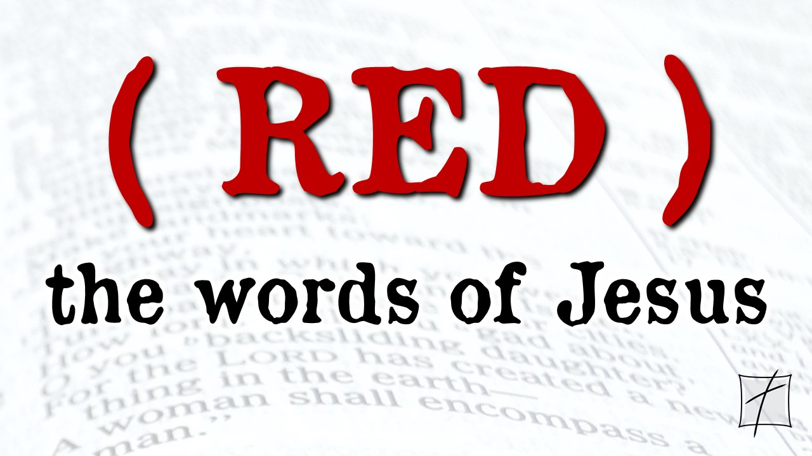

Step back and realize – it’s __________
And which of you by worrying can add a single hour to his life’s span? If then you cannot do even a very little thing, why do you worry about other matters?
(Luke 12:25-26)

Focus on God’s attention to ______________
And why are you worried about clothing? Observe how the lilies of the field grow; they do not toil nor do they spin, yet I say to you that not even Solomon in all his glory clothed himself like one of these. But if God so clothes the grass of the field, which is alive today and tomorrow is thrown into the furnace, will He not much more clothe you? You of little faith! Do not worry then, saying, ‘What will we eat?’ or ‘What will we drink?’ or ‘What will we wear for clothing?’ For the Gentiles eagerly seek all these things; for your heavenly Father knows that you need all these things. (Luke 12:28-32)

And He said: “Truly I tell you, unless you change and become like little children, you will never enter the kingdom of heaven.” (Matt 18:3)

Focus on your ____________ in His eyes
For this reason I say to you, do not be worried about your life, as to what you will eat or what you will drink; nor for your body, as to what you will put on. Is not life more than food, and the body more than clothing? (Matt 6:25)

Look at the birds of the air, that they do not sow, nor reap nor gather into barns, and yet your heavenly Father feeds them. Are you not worth much more than they?
(Matt 6:26)

Are not two sparrows sold for a penny? Yet not one of them will fall to the ground outside your Father’s care. And even the very hairs of your head are all numbered. So don’t be afraid; you are worth more than many sparrows. (Matt 10:29-31 NIV)

Lean in to the __________ ______________
But the Helper, the Holy Spirit, whom the Father will send in My name, He will teach you all things, and bring to your remembrance all that I said to you. Peace I leave with you; My peace I give to you; not as the world gives do I give to you. Do not let your heart be troubled, nor let it be fearful. (John 14:26-27)

Learn the value of “________________________”
And He went a little farther, and fell on His face, and prayed, saying, “O My Father, if it be possible, let this cup pass from Me: nevertheless not as I will, but as Thou wilt.”
(Matt 26:39 KJV)

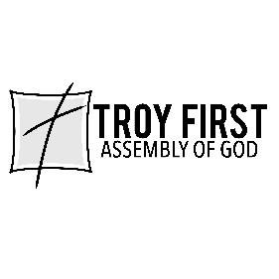

All scripture is from the New American Standard Version unless otherwise noted

September 13, 2020
Pastor Joseph Britain

So do not worry about tomorrow; for tomorrow will care for itself. Each day has enough trouble of its own. (Matt 6:34)

Give us this day our daily bread. (Matt 6:11)

The Greek word for ___________

In RED, “Do not worry” is a ________________
Do not worry then, saying, ‘What will we eat?’ or ‘What will we drink?’ or ‘What will we wear for clothing?’ (Matt 6:31)

Step back and realize – it’s __________
And which of you by worrying can add a single hour to his life’s span? If then you cannot do even a very little thing, why do you worry about other matters?
(Luke 12:25-26)

Focus on God’s attention to ______________
And why are you worried about clothing? Observe how the lilies of the field grow; they do not toil nor do they spin, yet I say to you that not even Solomon in all his glory clothed himself like one of these. But if God so clothes the grass of the field, which is alive today and tomorrow is thrown into the furnace, will He not much more clothe you? You of little faith! Do not worry then, saying, ‘What will we eat?’ or ‘What will we drink?’ or ‘What will we wear for clothing?’ For the Gentiles eagerly seek all these things; for your heavenly Father knows that you need all these things. (Luke 12:28-32)

And He said: “Truly I tell you, unless you change and become like little children, you will never enter the kingdom of heaven.” (Matt 18:3)

Focus on your ____________ in His eyes
For this reason I say to you, do not be worried about your life, as to what you will eat or what you will drink; nor for your body, as to what you will put on. Is not life more than food, and the body more than clothing? (Matt 6:25)

Look at the birds of the air, that they do not sow, nor reap nor gather into barns, and yet your heavenly Father feeds them. Are you not worth much more than they?
(Matt 6:26)

Are not two sparrows sold for a penny? Yet not one of them will fall to the ground outside your Father’s care. And even the very hairs of your head are all numbered. So don’t be afraid; you are worth more than many sparrows. (Matt 10:29-31 NIV)

Lean in to the __________ ______________
But the Helper, the Holy Spirit, whom the Father will send in My name, He will teach you all things, and bring to your remembrance all that I said to you. Peace I leave with you; My peace I give to you; not as the world gives do I give to you. Do not let your heart be troubled, nor let it be fearful. (John 14:26-27)

Learn the value of “________________________”
And He went a little farther, and fell on His face, and prayed, saying, “O My Father, if it be possible, let this cup pass from Me: nevertheless not as I will, but as Thou wilt.”
(Matt 26:39 KJV)

All scripture is from the New American Standard Version unless otherwise noted

