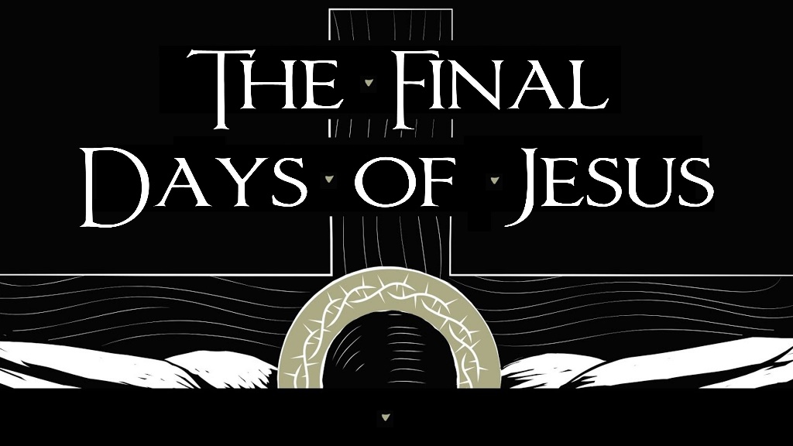

April 10, 2022
Pastor Joseph Britain

Raising __________________ from the dead
So Jesus, aware that they intended to come and take Him by force to make Him king, withdrew again to the mountain by Himself, alone - John 6:15

But He passed through their midst and went on His way – Luke 4:30

Then after this He said to the disciples, “Let’s go to Judea again.” The disciples said to Him, “Rabbi, the Jews were just now seeking to stone You, and yet You are going there again?” - John 11:7-8

So from that day on they planned together to kill Him - John 11:53

Entering in __________________ on Palm Sunday
The hour has come for the Son of Man to be glorified - John 12:23b

They give Him _____________
On the next day, when the large crowd that had come to the feast heard that Jesus was coming to Jerusalem, they took the branches of the palm trees and went out to meet Him, and began shouting, “Hosanna! Blessed is He who comes in the name of the Lord, indeed, the King of Israel!” - John 12:12-13

The righteous person will flourish like the palm tree - Ps 92:12a

Palms or _______________?

Thorns - a plant’s sharp defense mechanism,
designed to keep others at a distance

Don’t ever sacrifice _________________________
for understanding
I have told you all this so that you may have peace in Me. Here on earth you will have many trials and sorrows. But take heart, because I have overcome the world.”
- John 16:33 NLT

_______________________________
And He said, “Abba, Father, all things are possible for You. Take this cup away from Me; nevertheless, not what I will, but what You will.” - Mark 14:36 NKJV

God is clearly ___________ in the fire

All scripture is from the New International Version unless otherwise noted

