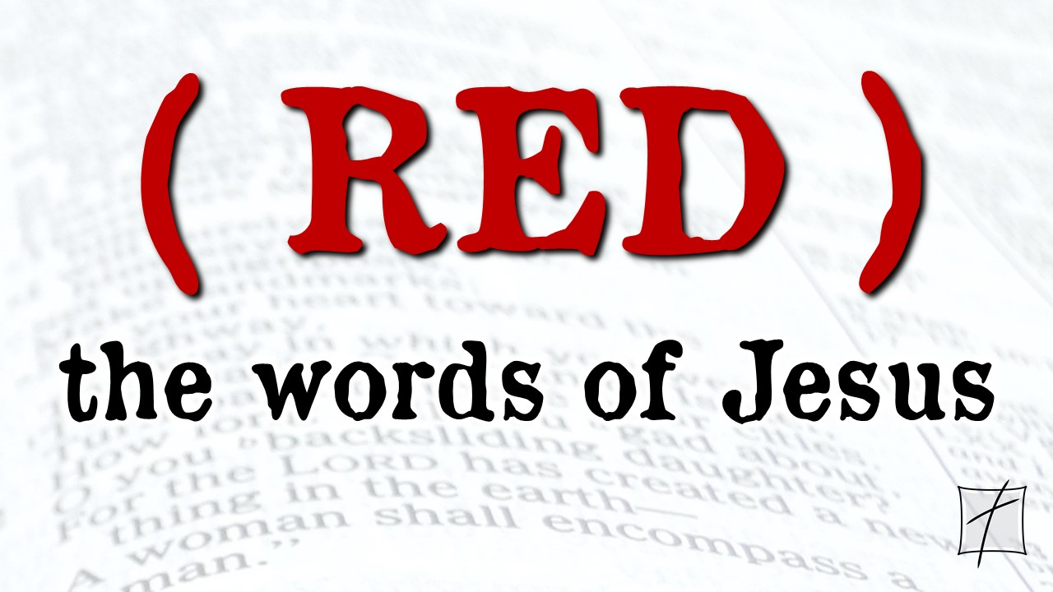
November 22, 2020
Pastor Joseph Britain

Jesus gave thanks for ____________________
Taking the five loaves and the two fish and looking up to heaven, He gave thanks and broke the loaves. Then He gave them to His disciples to distribute to the people. He also divided the two fish among them all. They all ate and were satisfied (Mark 6:41-42 NIV)

Jesus gave thanks for _______ ______________
Philip answered Him, “Two hundred denarii worth of bread is not enough for them, for each to receive just a little!” One of His disciples, Andrew, Simon Peter’s brother, said to Him, “There is a boy here who has five barley loaves and two fish; but what are these for so many people?” (John 6:7-9)

The next day the crowd that stood on the other side of the sea saw that there was no other small boat there except one, and that Jesus had not gotten into the boat with His disciples, but that His disciples had departed alone. Other small boats came from Tiberias near to the place where they ate the bread after the Lord had given thanks. (John 6:22-23)

Jesus thanked God for ____________________
So they removed the stone. And Jesus raised His eyes, and said, “Father, I thank You that You have heard Me. But I knew that You always hear Me; nevertheless, because of the people standing around I said it, so that they may believe that You sent Me.” And when He had said these things, He cried out with a loud voice, “Lazarus, come out!” Out came the man who had died, bound hand and foot with wrappings, and his face was wrapped around with a cloth. Jesus said to them, “Unbind him, and let him go.”
(John 11:41-44)

Jesus thanked God ____________ the miracle

Jesus thanked God for His own ______________
And when He had taken a cup and given thanks, He said, “Take this and share it among yourselves; for I say to you, I will not drink of the fruit of the vine from now on until the kingdom of God comes.” And when He had taken some bread and given thanks, He broke it and gave it to them, saying, “This is My body, which is being given for you; do this in remembrance of Me.” And in the same way He took the cup after they had eaten, saying, “This cup, which is poured out for you, is the new covenant in My blood.”
(Luke 22:17-20)

We do this by keeping our eyes on Jesus, the Champion who initiates and perfects our faith. Because of the joy awaiting Him, He endured the cross, disregarding its shame. Now He is seated in the place of honor beside God’s throne. (Heb 12:2 NLT)

Give thanks to the Lord, for He is good; for His mercy is everlasting. From my distress I called upon the Lord; The Lord answered me and put me in an open space. The Lord is for me; I will not fear; What can man do to me? The Lord is for me among those who help me; therefore I will look with satisfaction on those who hate me. It is better to take refuge in the Lord than to trust in people. All nations surrounded me; In the name of the Lord I will certainly fend them off. They surrounded me, yes, they surrounded me; In the name of the Lord I will certainly fend them off. They surrounded me like bees; They were extinguished like a fire of thorn bushes; In the name of the Lord I will certainly fend them off. You pushed me violently so that I was falling, but the Lord helped me. The Lord is my strength and song, and He has become my salvation. I will not die, but live, and tell of the works of the Lord. The Lord has disciplined me severely, but He has not turned me over to death. I will give thanks to You, for You have answered me, and You have become my salvation. A stone which the builders rejected has become the chief cornerstone. This came about from the Lord; It is marvelous in our eyes. This is the day which the Lord has made; Let’s rejoice and be glad in it. Blessed is the one who comes in the name of the Lord; We have blessed you from the house of the Lord. The Lord is God, and He has given us light; Bind the festival sacrifice to the horns of the altar with cords. You are my God, and I give thanks to You; You are my God, I exalt You. Give thanks to the Lord, for He is good; For His mercy is everlasting.
(Ps 118:1, 5-8, 10-14, 17-18, 21-24, 26-29)

After calling the apostles in, they flogged them and ordered them not to speak in the name of Jesus, and then released them. (Acts 5:40b)

So they went on their way from the presence of the Council, rejoicing that they had been considered worthy to suffer shame for His name. (Acts 5:41)

All scripture is from the New American Standard Version unless otherwise noted

