February 24, 2021
Pastor Joseph Britain

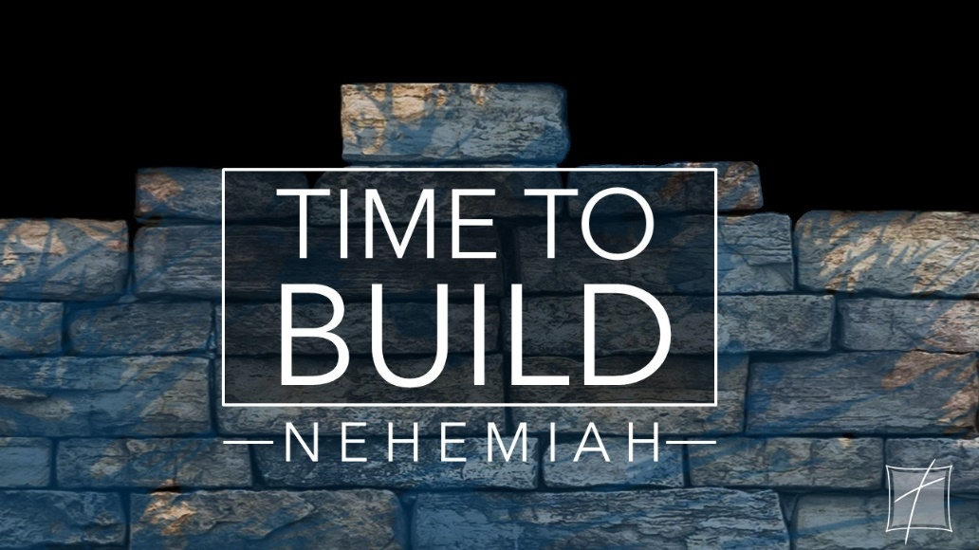
A _______________________ soul
In the world you have tribulation, but take courage; I have overcome the world
(John 16:33b)

Opposition from the _________________
Now it came about that when Sanballat heard that we were rebuilding the wall, he became furious and very angry, and he mocked the Jews. And he spoke in the presence of his brothers and the wealthy people of Samaria and said, “What are these feeble Jews doing? Are they going to restore the temple for themselves? Can they offer sacrifices? Can they finish it in a day? Can they revive the stones from the heaps of rubble, even the burned ones?” Now Tobiah the Ammonite was near him, and he said, “Even what they are building - if a fox were to jump on it, it would break their stone wall down!” (Ne 4:1-3)

... they have demoralized the builders. (Ne 4:5b)

So we built the wall, and the entire wall was joined together to half its height, for the people had a mind to work. (Ne 4:6)

Opposition necessitates _____________
As for the builders, each wore his sword strapped to his waist as he built, while the trumpeter stood near me. And I said to the nobles, the officials, and the rest of the people, “The work is great and extensive, and we are separated on the wall far from one another. At whatever place you hear the sound of the trumpet, assemble to us there. Our God will fight for us.” (Ne 4:18-20)

Watch out for ___________________ conflict
Then I was very angry when I heard their outcry and these words. So I thought it over and contended with the nobles and the leading people, and said to them, “You are lending at interest, each to his brother!” Therefore, I held a great assembly against them. And I said to them, “We, according to our ability, have redeemed our Jewish brothers who were sold to the nations; now would you even sell your brothers that they may be sold to us?” Then they were silent and could not find a word to say. (Ne 5:6-8)

Guard against ____________________________
Sanballat and Geshem sent a message to me, saying, “Come, let’s meet together at Chephirim in the plain of Ono.” But they were plotting to harm me. (Ne 6:2)

It is reported among the nations, and Gashmu says, that you and the Jews intend to rebel; for that reason you are rebuilding the wall. And you are to be their king, according to these reports. (Ne 6:6b)

“Let’s meet together in the house of God, within the temple, and let’s close the doors of the temple, for they are coming to kill you, and they are coming to kill you at night.” (Ne 6:10b)

But I said, “Should a man like me flee? And who is there like me who would go into the temple to save his own life? I will not go in.” Then I realized that God certainly had not sent him, but he uttered his prophecy against me because Tobiah and Sanballat had hired him. He was hired for this reason, that I would become frightened and act accordingly and sin, so that they might have an evil report in order that they could taunt me. (Ne 6:11-13)

______________ to give up
Only be strong and very courageous (Josh 1:7a)

And David was greatly distressed; for the people spake of stoning him, because the soul of all the people was grieved, every man for his sons and for his daughters: but David encouraged himself in the Lord his God. (1Sam 30:6 KJV)

All scripture is from the New American Standard Version unless otherwise noted

