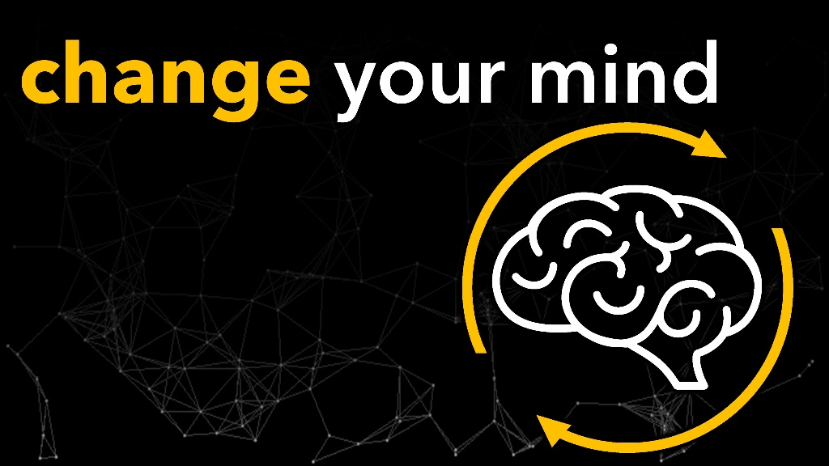

April 27, 2022
Pastor Joseph Britain

For as he thinks within himself, so he is. - Prov 23:7a

Things You Can Do to Literally Change Your Brain

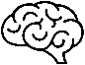
_____________________
No discipline is enjoyable while it is happening - it’s painful! But afterward there will be a peaceful harvest of right living for those who are trained in this way. So take a new grip with your tired hands and strengthen your weak knees. - Heb 12:11-12

Get some _____________
It is useless for you to work so hard from early morning until late at night, anxiously working for food to eat; for God gives rest to His loved ones - Ps 127:2

In peace I will lie down and sleep, for You alone, O Lord, will keep me safe - Ps 4:8

Take time to _____________________
May the words of my mouth and the meditation of my heart be pleasing to You, O Lord, my rock and my redeemer - Ps 19:14

Spend some time with ______________
(Elisha speaking) “Now bring me someone who can play the harp.” While the harp was being played, the power of the Lord came upon Elisha - 2Ki 3:15

Spend some time wandering in ________________
He lets me lie down in green pastures; He leads me beside quiet waters. He restores my soul - Ps 23:2-3a

Stop ________________________________
Look straight ahead, and fix your eyes on what lies before you - Prov 4:25

Consume a bit less ______________
You say, “I am allowed to do anything” - but not everything is good for you. And even though “I am allowed to do anything,” I must not become a slave to anything. - 1Cor 6:12

__________________ that you can
I don’t mean to say that I have already achieved these things or that I have already reached perfection. But I press on to possess that perfection for which Christ Jesus first possessed me. No, dear brothers and sisters, I have not achieved it, but I focus on this one thing: Forgetting the past and looking forward to what lies ahead, I press on to reach the end of the race and receive the heavenly prize for which God, through Christ Jesus, is calling us. - Php 3:12-14

All scripture is from the New Living Translation unless otherwise noted

