August 12, 2020
Pastor Joseph Britain

Two main themes – _______________ and _______
For even as the body is one and yet has many members, and all the members of the body, though they are many, are one body, so also is Christ. For by one Spirit we were all baptized into one body, whether Jews or Greeks, whether slaves or free, and we were all made to drink of one Spirit. For the body is not one member, but many. (1Cor 12:12-14)

Body parts’ ________________ are irrelevant
If the foot says, “Because I am not a hand, I am not a part of the body,” it is not for this reason any the less a part of the body. And if the ear says, “Because I am not an eye, I am not a part of the body,” it is not for this reason any the less a part of the body. If the whole body were an eye, where would the hearing be? If the whole were hearing, where would the sense of smell be? But now God has placed the members, each one of them, in the body, just as He desired. If they were all one member, where would the body be? But now there are many members, but one body. And the eye cannot say to the hand, “I have no need of you”; or again the head to the feet, “I have no need of you.” (1Cor 12:15-21)

____________ can be deceiving
On the contrary, it is much truer that the members of the body which seem to be weaker are necessary; and those members of the body which we deem less honorable, on these we bestow more abundant honor, and our less presentable members become much more presentable, whereas our more presentable members have no need of it. But God has so composed the body, giving more abundant honor to that member which lacked (1Cor 12:22-24)

No __________________ in the Body
So that there may be no division in the body, but that the members may have the same care for one another. And if one member suffers, all the members suffer with it; if one member is honored, all the members rejoice with it. (1Cor 12:25-26)

Everyone has __________________ -

No one has ____________________
Now you are Christ’s body, and individually members of it. And God has appointed in the church, first apostles, second prophets, third teachers, then miracles, then gifts of healings, helps, administrations, various kinds of tongues. All are not apostles, are they? All are not prophets, are they? All are not teachers, are they? All are not workers of miracles, are they? All do not have gifts of healings, do they? All do not speak with tongues, do they? All do not interpret, do they? (1Cor 12:27-30)

A more __________________ way
But earnestly desire the greater gifts. And I show you a still more excellent way. (1Cor 12:31)

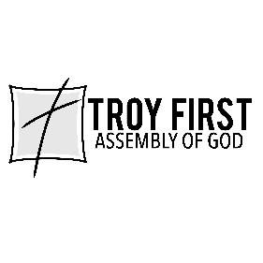

All scripture is from the New American Standard Version unless otherwise noted

