April 20, 2022
Pastor Joseph Britain

For as he thinks within himself, so he is. - Prov 23:7a

RECAP of Previous Messages
Your life moves in the direction of your strongest thoughts
You can’t have a positive life with a negative mind
Our brain functions in pathways
Do not conform to the pattern of this world, but be transformed by the renewing of your mind - Rom 12:2 NIV
Set our mind
Set your minds on the things that are above, not on the things that are on earth - Col 3:2
Train our mind
Memorize God’s Word

Meditate on God’s Word

Cognitive bias

ReFraming

Your ____________________ dialogue

Listen to yourself ___________

Preach to yourself ___________
Bless the Lord, my soul, and all that is within me, bless His holy name. Bless the Lord, my soul, and do not forget any of His benefits; Who pardons all your guilt, Who heals all your diseases; Who redeems your life from the pit, Who crowns you with favor and compassion; Who satisfies your years with good things, so that your youth is renewed like the eagle. - Ps 103:1-5

May the words of my mouth and the meditation of my heart be acceptable in Your sight, Lord, my rock and my Redeemer - Ps 19:14

You can’t be __________________
The heart is more deceitful than all else and is desperately sick; Who can understand it? - Jer 17:9

One who trusts in his own heart is a fool, but one who walks wisely will flee to safety - Prov 28:26

For from within, out of the hearts of people, come the evil thoughts, acts of sexual immorality, thefts, murders, acts of adultery, deeds of greed, wickedness, deceit, indecent behavior, envy, slander, pride, and foolishness. All these evil things come from within and defile the person. - Mark 7:21-23

And David was greatly distressed; for the people spoke of stoning him, because the soul of all the people was grieved, every man for his sons and for his daughters: but David encouraged himself in the Lord his God - 1Sam 30:6 KJV

Let your internal dialogue be __________________
➢ And be not drunk with wine, wherein is excess; but be filled with the Spirit; Speaking to yourselves in psalms and hymns and spiritual songs, singing and making melody in your heart to the Lord; Giving thanks always for all things unto God and the Father in the name of our Lord Jesus Christ - Eph 5:18-20 KJV

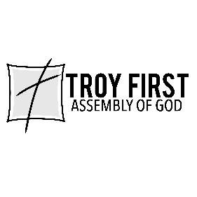

All scripture is from the New International Version unless otherwise noted

