September 2, 2020
Pastor Joseph Britain

What _____ Tongues?
For one who speaks in a tongue does not speak to men but to God (1Cor 14:2a)

The ______________ of language
For if I pray in a tongue, my spirit prays, but my mind is unfruitful. (1Cor 14:14)

Who is ____________ and who is being spoken ____

Tongues & Interpretation - The _________ Meeting
But to each one is given the manifestation of the Spirit for the common good. (1Cor 12:7)

To another various kinds of tongues, and to another the interpretation of tongues.
(1Cor 12:10)

All do not speak with tongues, do they? (1Cor 12:30)

But now, brethren, if I come to you speaking in tongues, what will I profit you unless I speak to you either by way of revelation or of knowledge or of prophecy or of teaching? (1Cor 14:6)

Therefore let one who speaks in a tongue pray that he may interpret. (1Cor 14:13)

I thank God, I speak in tongues more than you all; however, in the church I desire to speak five words with my mind so that I may instruct others also, rather than ten thousand words in a tongue. (1Cor 14:18-19)

Therefore if the whole church assembles together and all speak in tongues, and ungifted men or unbelievers enter, will they not say that you are mad? (1Cor 14:23)

If anyone speaks in a tongue, it should be by two or at the most three, and each in turn, and one must interpret; but if there is no interpreter, he must keep silent in the church; and let him speak to himself and to God. (1Cor 14:27-28)

My personal ____________ Language

– My ______________ Devotions
For one who speaks in a tongue does not speak to men but to God; for no one understands, but in the Spirit he speaks mysteries. (1Cor 14:2)

For if I pray in a tongue, my spirit prays, but my mind is unfruitful. What is the outcome then? I will pray with the spirit and I will pray with the mind also; I will sing with the spirit and I will sing with the mind also (1Cor 14:14-15)

Therefore, brethren, desire earnestly to prophesy, and do not forbid to speak with tongues. Let all things be done decently and in order. (1Cor 14:39-40 NKJV)

All of them were filled with the Holy Spirit and began to speak in other tongues as the Spirit enabled them. (Acts 2:4 NIV)

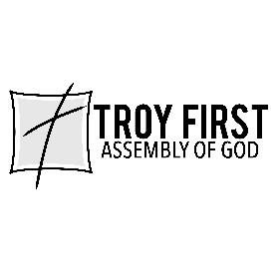

All scripture is from the New American Standard Version unless otherwise noted

