Therefore there is now no condemnation at all for those who are in Christ Jesus. For the law of the Spirit of life in Christ Jesus has set you free from the law of sin and of death. For what the Law could not do, weak as it was through the flesh, God did: sending His own Son in the likeness of sinful flesh and as an offering for sin, He condemned sin in the flesh, so that the requirement of the Law might be fulfilled in us who do not walk according to the flesh but according to the Spirit - Rom 8:1-4
Moses wrote on tablets of ____________
Jesus ___________________ our stony hearts,
then writes on those
Moreover, I will give you a new heart and put a new spirit within you; and I will remove the heart of stone from your flesh and give you a heart of flesh. And I will put My Spirit within you and bring it about that you walk in My statutes, and are careful and follow My ordinances. - Ez 36:26-27

But now He has obtained a more excellent ministry, to the extent that He is also the mediator of a better covenant, which has been enacted on better promises.
I will put My laws into their minds, and write them on their hearts. And I will be their God, and they shall be My people. - Heb 8:6 & 10b

Moses was the faithful ______________
Jesus is the ______
Now Moses was faithful in all God’s house as a servant, for a testimony of those things which were to be spoken later; but Christ was faithful as a Son over His house - whose house we are, if we hold firmly to our confidence and the boast of our hope- Heb 3:5-6

Moses ____________ for help
Jesus just ________, and thanked God for His help

Moses’ followers all end up __________
Jesus’ followers __________ forever
Such is the confidence we have toward God through Christ - who also made us adequate as servants of a new covenant, not of the letter but of the Spirit; for the letter kills, but the Spirit gives life - 2Cor 3:4 & 6

All scripture is from the New American Standard Bible unless otherwise noted

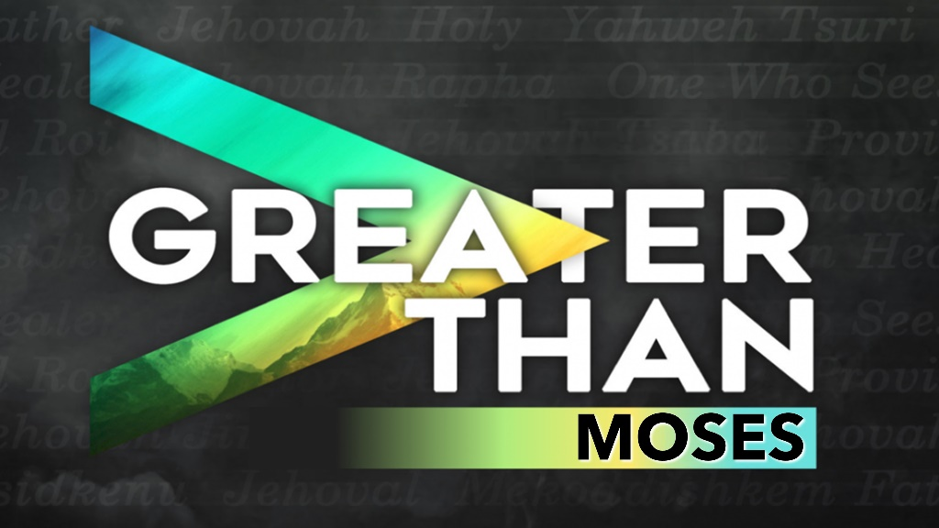

February 9, 2022
Pastor Joseph Britain

SIMILARITIES – Both Moses and Jesus:
Appeared after 400 years of God’s
apparent ________________
Gen 15:13 / Luke 1:5

As ______________, faced the murderous plan of
a wicked king
Ex 1:22 / Matt 2:16

As ________________, spent time in Egypt for their own safety
Ex 2:10 / Matt 2:15

___________ 40 days before bringing God’s Word
Ex 34:28 / Matt 4:2

Sent as ________________, speaking God’s Word
Ex 3:15 / Matt 21:11
I will raise up a prophet like you from among their fellow Israelites. I will put my words in his mouth, and he will tell the people everything I command him. I will personally deal with anyone who will not listen to the messages the prophet proclaims on my behalf. - Deut 18:18-19
Sent as ____________________
Ex 3:10 / Matt 1:21

Take their people through the ____________
Ex 14:21-31 / Matt 28:19-20

Were _____________________
Ex 3:1 / John 10:11

Performed _______________ – to testify and help
Ex 4:17 / John 5:36

Instituted ____________ Covenants,
bringing deliverance
Ex 24:8 / Matt 26:28

Affirmed by God by audible ____________
Ex 19:9 / Matt 17:5

Gave up great ______________ to do God’s Will
Heb 11:26 / 2Cor 8:9

Were initially _________________ by God’s people,
the Jews
Ex 5:21 / John 1:11

____________________ by their blood family
Num 12:2 / Mark 3:21

Willing to ________ for the people
Ex 32:32 / John 11:50

Miraculously provided ___________
Ex 16:12 / Matt 14:20

Were accepted by _______________
Ex 18:9 / Mark 2:15-16

______________ a non-Jewish wife
Num 12:1 / Eph 2:11-15

_____________ with God’s glory
Ex 34:35 / Matt 17:2

50 days after deliverance,
equips people to _____________
Lev 23:15-22 / Acts 2

DIFFERENCES – Between Moses and Jesus:

Moses turned water to ___________ = thirst for all
Jesus ________ His blood = internal springs of
Living Water for all

Moses gave us the _______
Jesus gave us ____________ and ____________
For the Law was given through Moses; grace and truth were realized through Jesus Christ - John 1:17

Because by the works of the Law none of mankind will be justified in His sight; for through the Law comes knowledge of sin - Rom 3:20

Therefore the Law has become our guardian to lead us to Christ, so that we may be justified by faith. But now that faith has come, we are no longer under a guardian. For you are all sons and daughters of God through faith in Christ Jesus. Gal 3:24-26

