February 20, 2022
Pastor Joseph Britain

Give us this day our daily bread - Matt 6:11

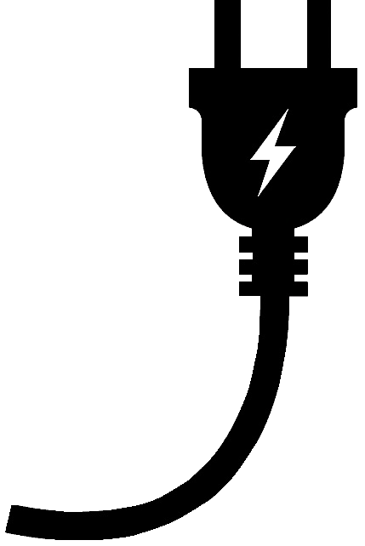

The _____________ part is important
Your clothing did not wear out on you, nor did your foot swell these forty years - Deut 8:4

Then the Lord said to Moses, “Behold, I will rain bread from heaven for you; and the people shall go out and gather a day’s portion every day, so that I may test them, whether or not they will walk in My instruction” - Ex 16:4

He humbled you, causing you to hunger and then feeding you with manna, which neither you nor your ancestors had known, to teach you that man does not live on bread alone but on every word that comes from the mouth of the Lord - Deut 8:3 NIV

Don’t miss the double __________________
It is written: “Man shall not live on bread alone, but on every word that comes out of the mouth of God.” - Matt 4:4b

I am the bread of life. Your fathers ate the manna in the wilderness, and they died. This is the bread that comes down out of heaven, so that anyone may eat from it and not die. I am the living bread that came down out of heaven; if anyone eats from this bread, he will live forever - John 6:48-51a

Sometimes it’s about ____________________
Then the word of the Lord came to him, saying, “Arise, go to Zarephath, which belongs to Sidon, and stay there; behold, I have commanded a widow there to provide food for you.” So he arose and went to Zarephath, and when he came to the entrance of the city, behold, a widow was there gathering sticks; and he called to her and said, “Please get me a little water in a cup, so that I may drink.” As she was going to get it, he called to her and said, “Please bring me a piece of bread in your hand.” But she said, “As the Lord your God lives, I have no food, only a handful of flour in the bowl and a little oil in the jar; and behold, I am gathering a few sticks so that I may go in and prepare it for me and my son, so that we may eat it and die.” However, Elijah said to her, “Do not fear; go, do as you have said. Just make me a little bread loaf from it first and bring it out to me, and afterward you may make one for yourself and for your son. For this is what the Lord, the God of Israel says: ‘The bowl of flour shall not be used up, nor shall the jar of oil become empty, until the day that the Lord provides rain on the face of the earth.’” So she went and did everything in accordance with the word of Elijah, and she and he and her household ate for many days. The bowl of flour was not used up, nor did the jar of oil become empty, in accordance with the word of the Lord which He spoke through Elijah. - 1Ki 17:8-16

Do not worry then, saying, ‘What are we to eat?’ or ‘What are we to drink?’ or ‘What are we to wear for clothing?’ For the Gentiles eagerly seek all these things; for your heavenly Father knows that you need all these things. But seek first His kingdom and His righteousness, and all these things will be provided to you. - Matt 6:31-33

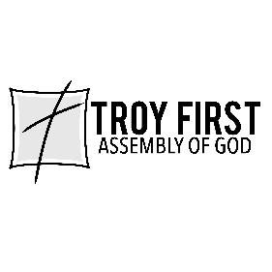

All scripture is from the New International Version unless otherwise noted

