Adam’s act produced ________________________

Jesus’ act produced __________________________

and ____________________________
For if by the offense of the one, death reigned through the one, much more will those who receive the abundance of grace and of the gift of righteousness reign in life through the One, Jesus Christ. So then, as through one offense the result was condemnation to all mankind, so also through one act of righteousness the result was justification of life to all mankind. For as through the one man’s disobedience the many were made sinners, so also through the obedience of the One the many will be made righteous - Rom 5:17-19

All scripture is from the New American Standard Bible unless otherwise noted

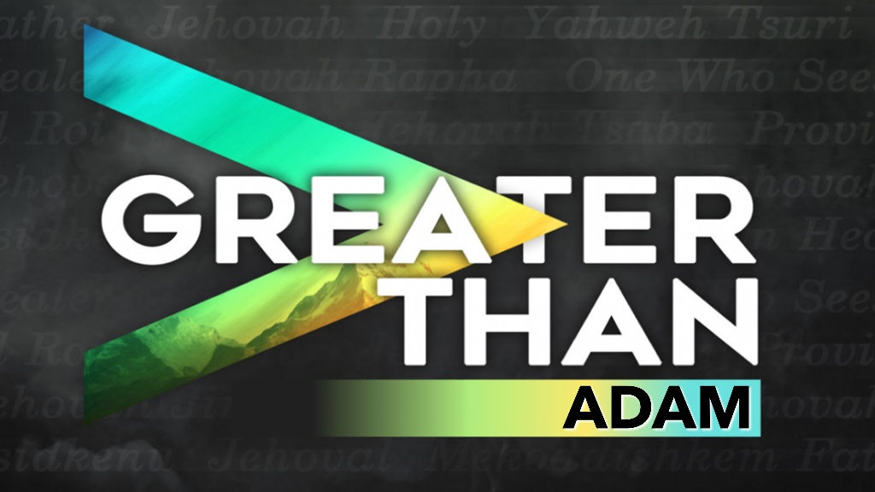

January 19, 2022
Pastor Joseph Britain

SIMILARITIES – Both Adam and Jesus:

had a miraculous __________,

from the same ____________
Then the Lord God formed the man of dust from the ground, and breathed into his nostrils the breath of life; and the man became a living person - Gen 2:7

The Holy Spirit will come upon you, and the power of the Most High will overshadow you; for that reason also the holy Child will be called the Son of God - Luke 1:35b

were created ______________, ________________

and __________
So God created man in His own image, in the image of God He created him; male and female He created them - Gen 1:27

I and the Father are one - John 10:30

acted on behalf of ________ humanity
For since by a man death came, by a man also came the resurrection of the dead. For as in Adam all die, so also in Christ all will be made alive - 1Cor 15:21-22
have descendants in their ________ image
When Adam had lived 130 years, he fathered a son in his own likeness, according to his image, and named him Seth - Gen 5:3

But as many as received Him, to them He gave the right to become children of God, to those who believe in His name - John 1:12

__________ with authority
Then God said, “Let Us make mankind in Our image, according to Our likeness; and let them rule over the fish of the sea and over the birds of the sky and over the livestock and over all the earth, and over every crawling thing that crawls on the earth” - Gen 1:26

And Jesus came up and spoke to them, saying, “All authority in heaven and on earth has been given to Me” - Matt 28:18

A sleep and a side wound produces a

beautiful __________
So the Lord God caused a deep sleep to fall upon the man, and he slept; then He took one of his ribs and closed up the flesh at that place. And the Lord God fashioned into a woman the rib which He had taken from the man, and brought her to the man - Gen 2:21-22

Yet one of the soldiers pierced His side with a spear, and immediately blood and water came out. - John 19:34

DIFFERENCES – Between Adam and Jesus:

Adam was made a ______________ Soul

Jesus was made a ________-_____________ Spirit
So also it is written: “The first man, Adam, became a living person.” The last Adam was a life-giving spirit. - 1Cor 15:45

Adam was ______________ – of the earth

Jesus was __________________ – of heaven
The first man is from the earth, earthy; the second man is from heaven. As is the earthy one, so also are those who are earthy; and as is the heavenly one, so also are those who are heavenly. Just as we have borne the image of the earthy, we will also bear the image of the heavenly. Now I say this, brothers and sisters, that flesh and blood cannot inherit the kingdom of God; nor does the perishable inherit the imperishable - 1Cor 15:47-50

Adam gives all men _________________

Jesus gives all men ______________ and choice
Behold, I was brought forth in iniquity, and in sin my mother conceived me –
Ps 51:5 NKJV

All we like sheep have gone astray; We have turned, every one, to his own way;
And the Lord has laid on Him the iniquity of us all - Is 53:6 NKJV

Thanks be to God, who gives us the victory through our Lord Jesus Christ - 1Cor 15:57

Adam’s act produced ____________

Jesus’ act produced ___________
Therefore, just as through one man sin entered into the world, and death through sin, and so death spread to all mankind, because all sinned - Rom 5:12

But the gracious gift is not like the offense. For if by the offense of the one the many died, much more did the grace of God and the gift by the grace of the one Man, Jesus Christ, overflow to the many - Rom 5:15

Adam’s act produced __________________

Jesus’ act produced the Free Gift of ____________
The gift is not like that which came through the one who sinned; for on the one hand the judgment arose from one offense, resulting in condemnation, but on the other hand the gracious gift arose from many offenses, resulting in justification - Rom 5:16

