October 7, 2020
Pastor Joseph Britain

But the fruit of the Spirit is love, joy, peace, patience, kindness, goodness, faithfulness, gentleness, self-control; against such things there is no law. (Gal 5:22-23)

So I say, let the Holy Spirit guide your lives. Then you won’t be doing what your sinful nature craves. The sinful nature wants to do evil, which is just the opposite of what the Spirit wants. And the Spirit gives us desires that are the opposite of what the sinful nature desires. These two forces are constantly fighting each other, so you are not free to carry out your good intentions. But when you are directed by the Spirit, you are not under obligation to the law of Moses. When you follow the desires of your sinful nature, the results are very clear: sexual immorality, impurity, lustful pleasures, idolatry, sorcery, hostility, quarreling, jealousy, outbursts of anger, selfish ambition, dissension, division, envy, drunkenness, wild parties, and other sins like these. Let me tell you again, as I have before, that anyone living that sort of life will not inherit the Kingdom of God. But the Holy Spirit produces this kind of fruit in our lives: love, joy, peace, patience, kindness, goodness, faithfulness, gentleness, and self-control. There is no law against these things! Those who belong to Christ Jesus have nailed the passions and desires of their sinful nature to his cross and crucified them there. Since we are living by the Spirit, let us follow the Spirit’s leading in every part of our lives. (Gal 5:16-25)

The ____________ of the fruit
(Jesus speaking) I am the vine, you are the branches; he who abides in Me and I in him, he bears much fruit, for apart from Me you can do nothing. (John 15:5)

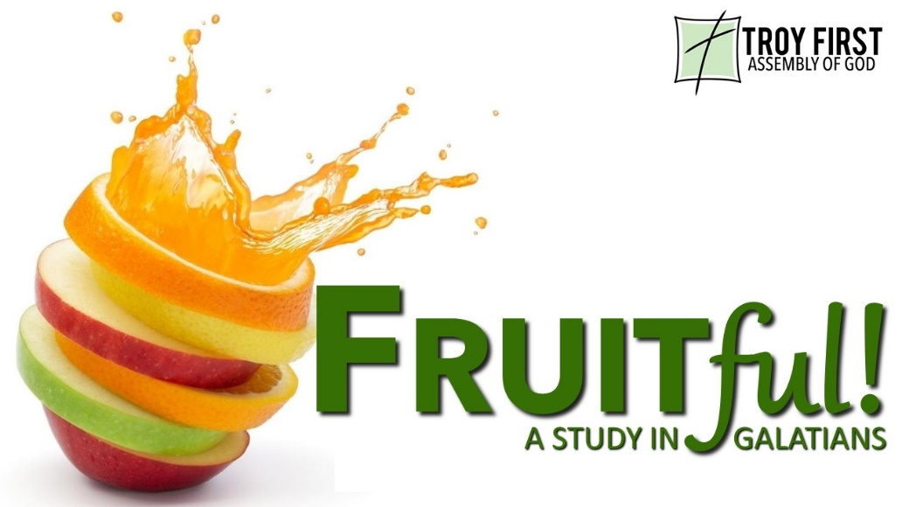

The _________ of the fruit
(Jesus speaking) Truly, truly, I say to you, unless a grain of wheat falls into the earth and dies, it remains alone; but if it dies, it bears much fruit. (John 12:24)

The __________________ of the fruit
(Jesus speaking) My Father is glorified by this, that you bear much fruit, and so prove to be My disciples. (John 15:8)

Fruit is an __________________ of who you are
(Jesus speaking) You will know them by their fruits. Grapes are not gathered from thorn bushes nor figs from thistles, are they? So every good tree bears good fruit, but the bad tree bears bad fruit. A good tree cannot produce bad fruit, nor can a bad tree produce good fruit. (Matt 7:16-18)

A Good Gardener ______________
(Jesus speaking) I am the true vine, and My Father is the vinedresser. Every branch in Me that does not bear fruit, He takes away; and every branch that bears fruit, He prunes it so that it may bear more fruit. My Father is glorified by this, that you bear much fruit, and so prove to be My disciples. (John 15:1-2)

Fruit contains seeds for even __________ plants
Then God said, “Let the earth sprout vegetation, plants yielding seed, and fruit trees on the earth bearing fruit after their kind with seed in them”; and it was so.
(Gen 1:11)

All scripture is from the New American Standard Version unless otherwise noted

