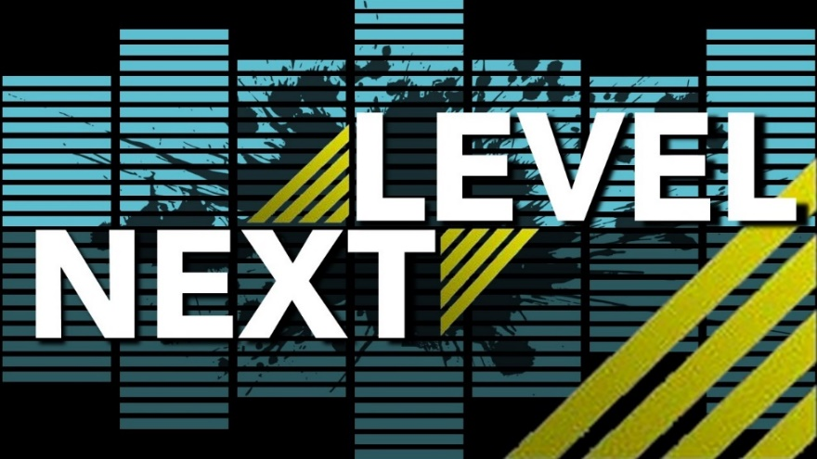

March 14, 2021
Pastor Joseph Britain

What If? - Why Not? - WOW

Do not call to mind the former things, or consider things of the past. Behold, I am going to do something new, now it will spring up; Will you not be aware of it? I will even make a roadway in the wilderness, rivers in the desert. (Is 43:18-19)

So Elisha said to her, “What shall I do for you? Tell me, what do you have in the house?” (2Ki 4:2a)

What If?
Taste and see that the Lord is good; How blessed is the man who takes refuge in Him! (Ps 34:8)

Build bigger ____________

Take greater ____________

We’ve ____________ done it that way before
Behold, I am going to do something new (Is 43:19a)

The method is not sacred – The message is

Fear of _________________

Never confuse a single defeat with a final defeat

Failure is not the opposite of success
– it’s PART of success

For a righteous person falls seven times and rises again (Prov 24:16a)

All scripture is from the New American Standard Version unless otherwise noted

