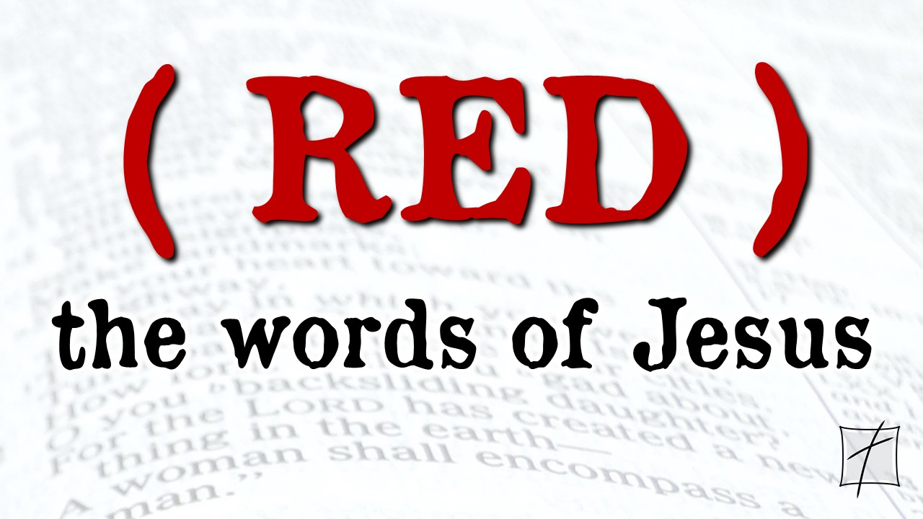

January 3, 2021
Pastor Joseph Britain

It’s only the _____________________
The first account I composed, Theophilus, about all that Jesus began to do and teach, until the day when He was taken up to heaven, after He had given orders by the Holy Spirit to the apostles whom He had chosen. (Acts 1:1-2)

It’s beginning for the _______________
For God does not change His mind about whom He chooses and blesses.
(Rom 11:29 GNT)

We’re chosen for a supernatural __________
The thief comes only to steal and kill and destroy; I have come that they may have life, and have it to the full. (John 10:10 NIV)

We’re chosen for a supernatural _____________
(Jesus praying to the Father) Just as You sent Me into the world, I am sending them into the world. (John 17:18 NLT)

Truly, truly I say to you, the one who believes in Me, the works that I do, he will do also; and greater works than these he will do; because I am going to the Father. (John 14:12)

We’re chosen for a supernatural __________
There is so much more I want to tell you, but you can’t bear it now. (John 16:12 NLT)

Jesus said, “Wait for the __________”
Gathering them together, He commanded them not to leave Jerusalem, but to wait for what the Father had promised, “Which,” He said, “you heard of from Me” (Acts 1:4)

But you will receive power when the Holy Spirit has come upon you; and you shall be My witnesses both in Jerusalem, and in all Judea and Samaria, and even to the remotest part of the earth. (Acts 1:8)

The Holy Spirit gives ___________
It is the Spirit who gives life; the flesh is no help at all. The words that I have spoken to you are spirit and life. (John 6:63 ESV)

The Holy Spirit ____________ us for the mission

The Holy Spirit is our _________________
But the Helper, the Holy Spirit whom the Father will send in My name, He will teach you all things, and remind you of all that I said to you. (John 14:26)

______________ than having Jesus here
But I tell you the truth: it is to your advantage that I am leaving; for if I do not leave, the Helper will not come to you; but if I go, I will send Him to you. (John 16:7)

The undisputed _______________
It will come about after this that I will pour out My Spirit on all mankind; And your sons and your daughters will prophesy, your old men will have dreams, your young men will see visions. And even on the male and female servants I will pour out My Spirit in those days. (Joel 2:28-29)

He will baptize you with the Holy Spirit (Matt 3:11, Mark 1:8, Luke 3:16, John 1:33)

And behold, I am sending the promise of My Father upon you; but you are to stay in the city until you are clothed with power from on high. (Luke 24:49)

Gathering them together, He commanded them not to leave Jerusalem, but to wait for what the Father had promised, “Which,” He said, “you heard of from Me; for John baptized with water, but you will be baptized with the Holy Spirit not many days from now.” (Acts 1:4-5)

And suddenly a noise like a violent rushing wind came from heaven, and it filled the whole house where they were sitting. And tongues that looked like fire appeared to them, distributing themselves, and a tongue rested on each one of them. And they were all filled with the Holy Spirit and began to speak with different tongues, as the Spirit was giving them the ability to speak out. (Acts 2:2-4)

Now when the apostles in Jerusalem heard that Samaria had received the word of God, they sent them Peter and John, who came down and prayed for them that they would receive the Holy Spirit. (Acts 8:14-15)

So Ananias departed and entered the house, and after laying his hands on him said, “Brother Saul, the Lord Jesus, who appeared to you on the road by which you were coming, has sent me so that you may regain your sight and be filled with the Holy Spirit.” (Acts 9:17)

While Peter was still speaking these words, the Holy Spirit fell upon all those who were listening to the message. All the Jewish believers who came with Peter were amazed, because the gift of the Holy Spirit had also been poured out on the Gentiles. For they were hearing them speaking with tongues and exalting God. Then Peter responded, “Surely no one can refuse the water for these to be baptized, who have received the Holy Spirit just as we did, can he? (Acts 10:44-47)

He said to them, “Did you receive the Holy Spirit when you believed?” And they said to him, “On the contrary, we have not even heard if there is a Holy Spirit.” (Acts 19:2)

All scripture is from the New American Standard Version unless otherwise noted

