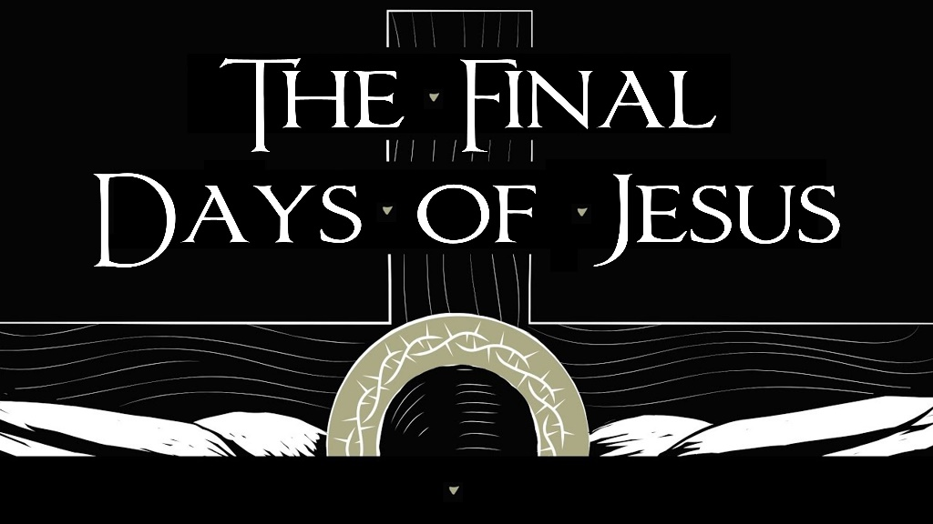

April 3, 2022
Pastor Joseph Britain

Jesus, Our Passover Lamb
Christ, our Passover Lamb, has been sacrificed for us - 1Cor 5:7b NLT

The Lord had also executed judgments against their gods - Num 33:4b

The final judgment is the ____________________
For the Lord will pass through to strike the Egyptians; but when He sees the blood on the lintel and on the two doorposts, the Lord will pass over the door and will not allow the destroyer to come in to your houses to strike you - Ex 12:23

The blood is a sign for ______
The blood shall be a sign for you on the houses where you live; and when I see the blood I will pass over you, and no plague will come upon you to destroy you when I strike the land of Egypt - Ex 12:13

The ___________

- The Lamb had to be a year old male without spot or blemish
Your lamb shall be an unblemished male a year old - Ex 12:5a

For as in Adam all die, so also in Christ all will be made alive - 1Cor 15:22

- The Lamb had to be a year old
For those whom He foreknew, He also predestined to become conformed to the image of His Son, so that He would be the firstborn among many brothers - Rom 8:29

- The Lamb had to die
- You couldn’t break a bone of the Lamb

- The Lamb had a specific timeline
Speak to all the congregation of Israel, saying, “On the tenth of this month they are, each one, to take a lamb for themselves, according to the fathers’ households, a lamb for each household - Ex 12:3

You shall keep it until the fourteenth day of the same month - Ex 12:6a

- The Lamb was to be roasted with fire, whole
Do not eat any of it raw or boiled at all with water, but rather roasted with fire, both its head and its legs along with its entrails - Ex 12:9

When He had disarmed the rulers and authorities, He made a public display of them, having triumphed over them through Him - Col 2:15

- The Lamb had to be eaten
They shall eat the flesh that same night, roasted with fire - Ex 12:8a

- You’re supposed to eat it ready to leave at any given moment
Now you shall eat it in this way: with your garment belted around your waist, your sandals on your feet, and your staff in your hand; and you shall eat it in a hurry - it is the Lord’s Passover - Ex 12:11

- One major difference
The life of every creature is in its blood. That is why I have said to the people of Israel, ‘You must never eat or drink blood, for the life of any creature is in its blood.’
- Lev 17:14a

And when He had taken a cup and given thanks, He gave it to them, saying, “Drink from it, all of you; for this is My blood of the covenant, which is being poured out for many for forgiveness of sins. - Matt 26:27-28

- The Lamb was sacrificed for a Family
So now you Gentiles are no longer strangers and foreigners. You are citizens along with all of God’s holy people. You are members of God’s family - Eph 2:19 NLT

- If your family is too small to finish a lamb, you were to share
If a family is too small to eat a whole animal, let them share with another family in the neighborhood - Ex 12:4a NLT

- The Lamb had to be without spot or blemish
For we do not have a high priest who cannot sympathize with our weaknesses, but One who has been tempted in all things just as we are, yet without sin - Heb 4:15

Knowing that you were not redeemed with perishable things like silver or gold from your futile way of life inherited from your forefathers, but with precious blood, as of a lamb unblemished and spotless, the blood of Christ - 1Pe 1:18-19’

All scripture is from the New International Version unless otherwise noted

