November 4, 2020
Pastor Joseph Britain

But the fruit of the Spirit is love, joy, peace, patience, kindness, goodness, faithfulness, gentleness, self-control; against such things there is no law. (Gal 5:22-23)

The original ____________ word(s) - macrothumia

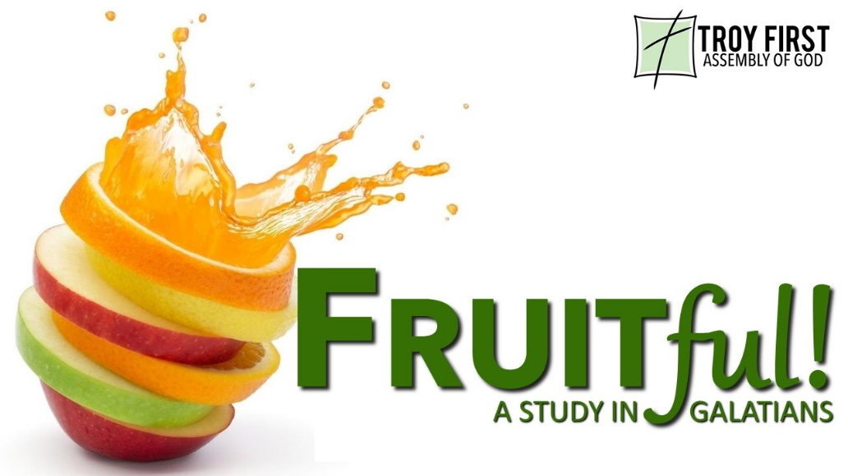

Patience = __________ tempered

The other _____________ word - hupomene
And not only this, but we also exult in our tribulations, knowing that tribulation brings about perseverance (Rom 5:3)

Now you followed my teaching, conduct, purpose, faith, patience, love, perseverance (2Tim 3:10)

Makes us more like _________

Jesus must become _______________ in our life
Let this mind be in you which was also in Christ Jesus (Php 2:5 NKJV)

Realize that patience is ___________ with other fruit
I have been crucified with Christ; and it is no longer I who live, but Christ lives in me (Gal 2:20a)

Lower the ___________________ of water in our pot
For this very reason, make every effort to add to your faith goodness; and to goodness, knowledge; and to knowledge, self-control; and to self-control, perseverance; and to perseverance, godliness; and to godliness, mutual affection; and to mutual affection, love. For if you possess these qualities in increasing measure, they will keep you from being ineffective and unproductive in your knowledge of our Lord Jesus Christ. (2Pe 1:5-8 NIV)

Count the __________
We urge you, brothers and sisters, admonish the unruly, encourage the fainthearted, help the weak, be patient with everyone. (1Thes 5:14)

Yet those who wait for the Lord will gain new strength . . . (Is 40:3a)

All scripture is from the New American Standard Version unless otherwise noted

